REALM: HOW TO PLAY

Components
The game includes the following components:
- 1x Game Board
- 2x 6-sided dice (D6)
- 1x 4-sided dice (D4)
- 1x Dragon marker
- 1x Dragon anger gauge
- 4x Kingdom markers
- 4x Unowned Forest tiles
- ?x Forest tiles (between 4 kingdoms)
- ?x Farm tiles (between all 4 kingdoms)
- ?x Mine tiles (between all 4 kingdoms)
- ?x Military base tiles (between all 4 kingdoms)
- ?x Wood resource cards
- ?x Stone resource cards
- ?x Soldier resource cards
- ?x Food resource cards
- ?x Skill cards

Setup
Set up the board with the unowned forests and dragon in the following arrangement. (Green = Forest, Purple = Dragon)
[Image is temporary placeholder.]
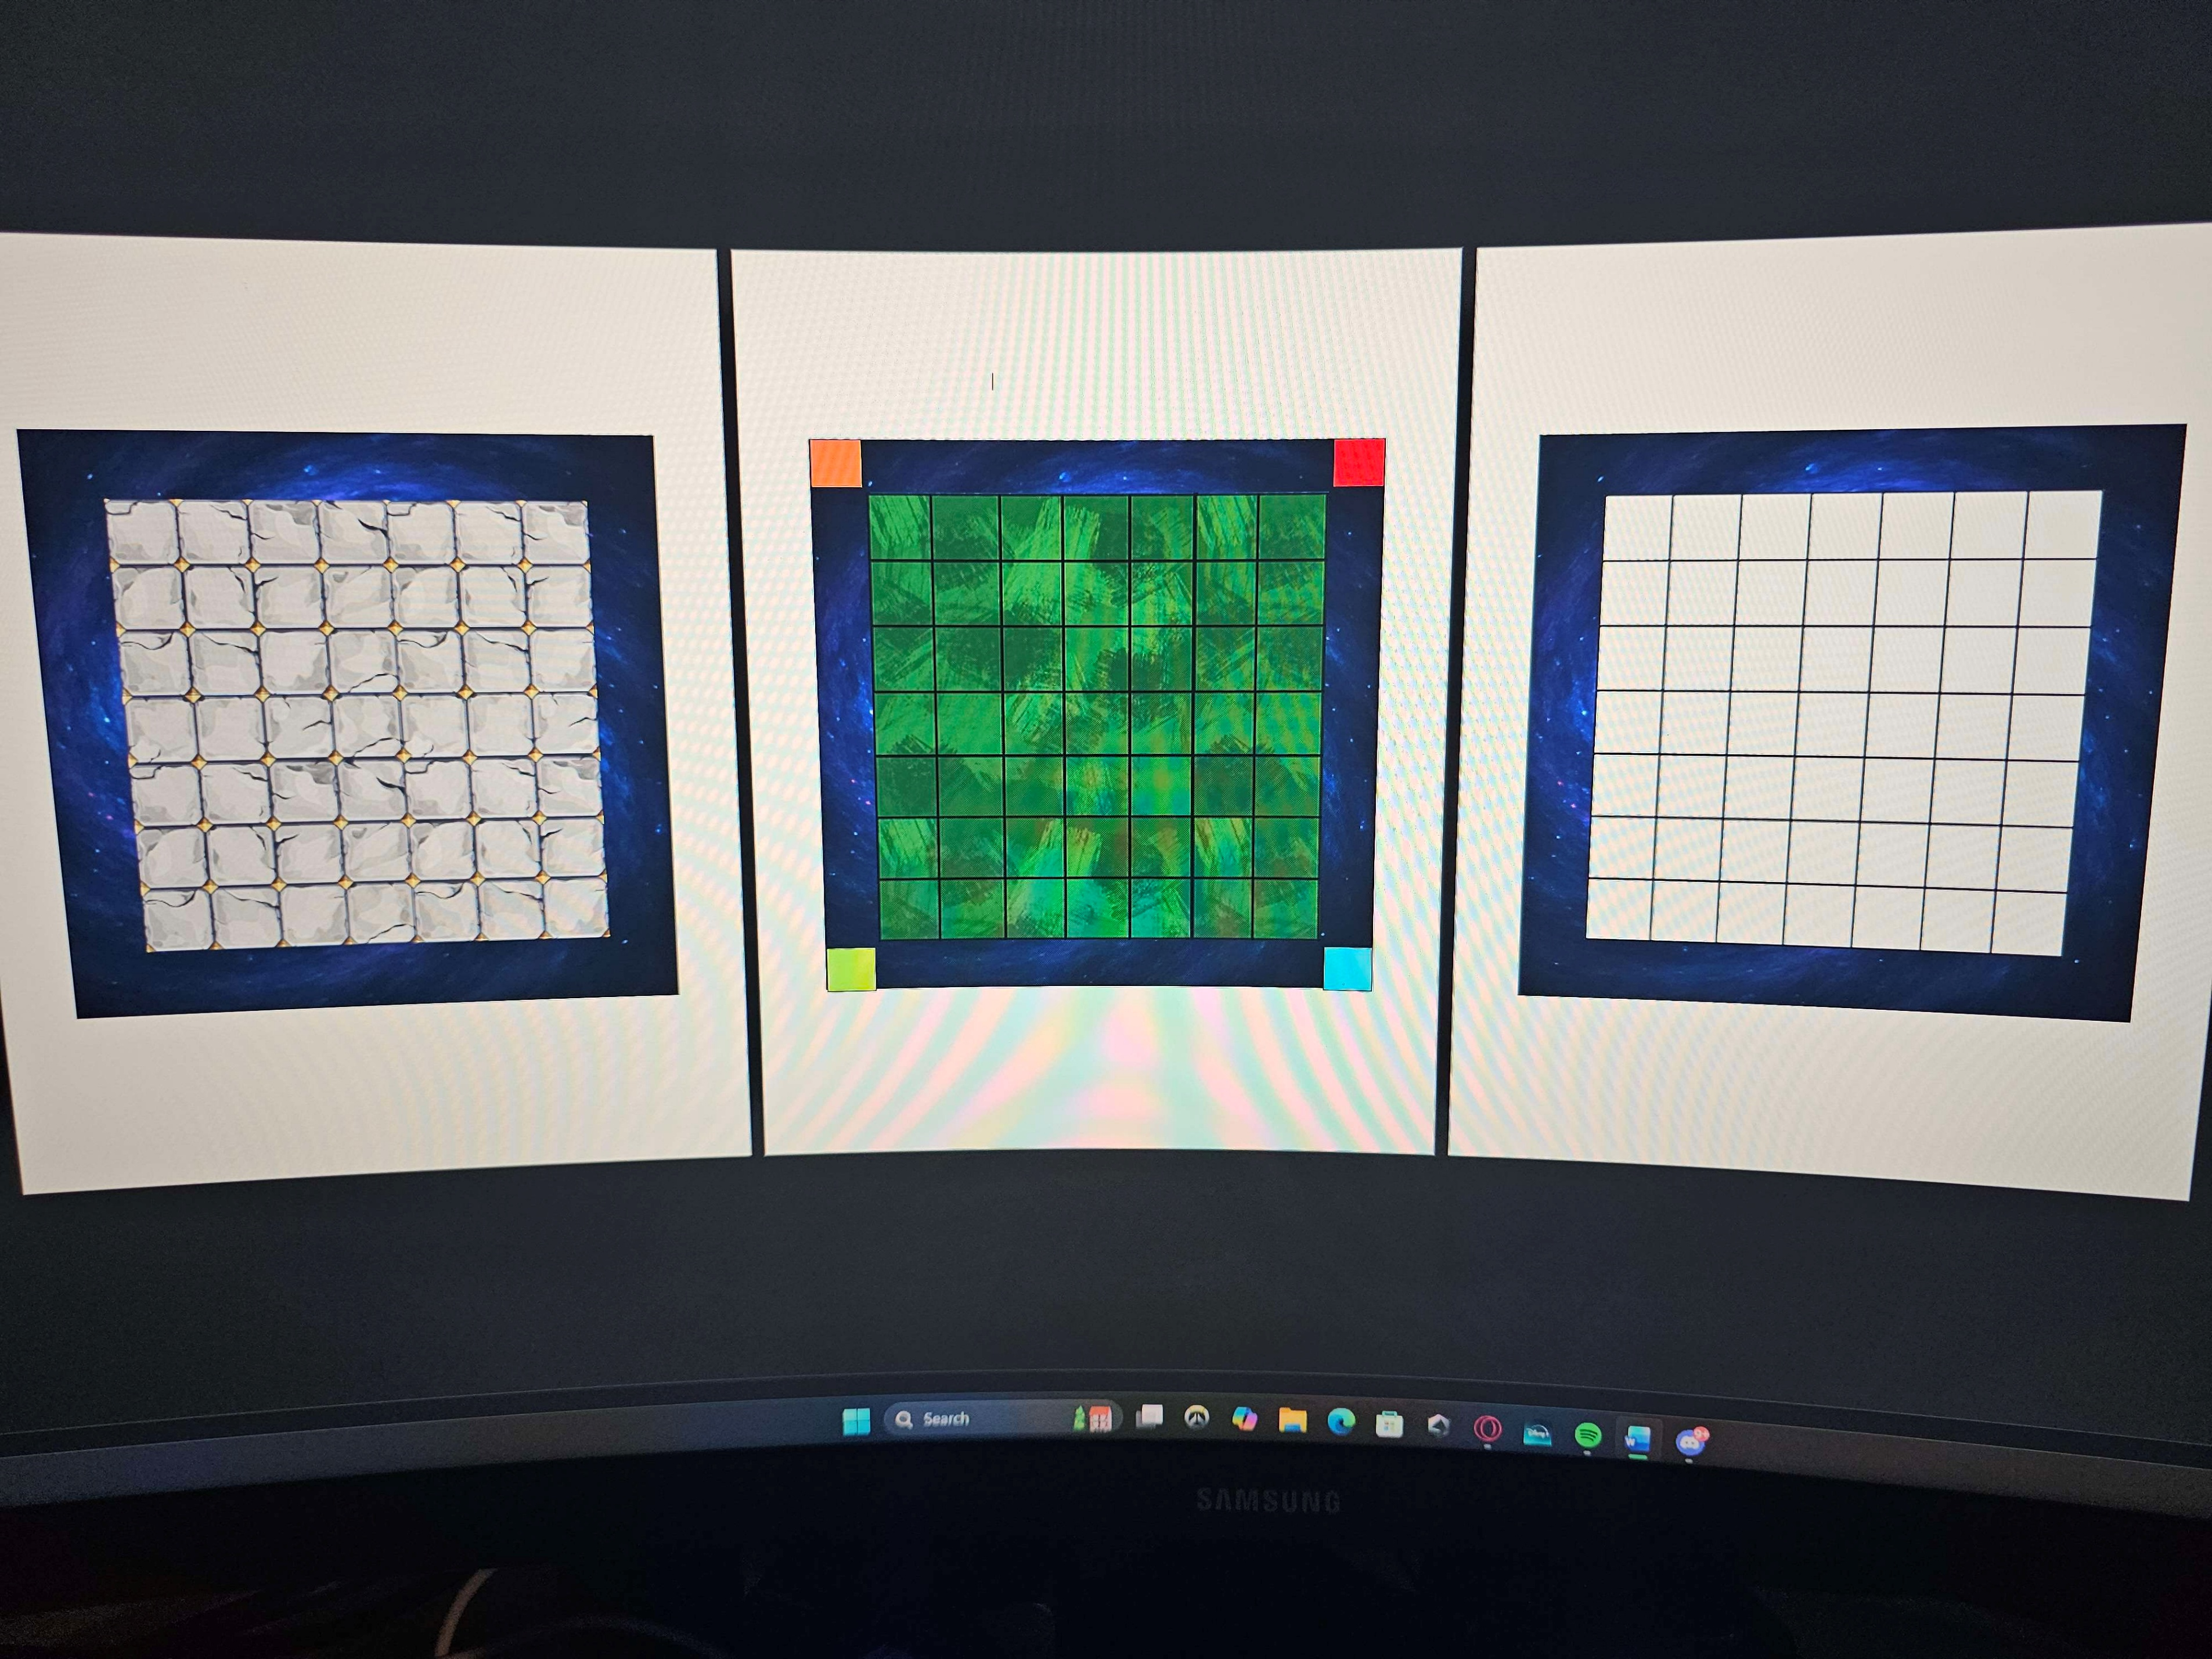

With the board in the above state, players each select a kingdom and place its corresponding statue on a square in the outer ring of the board. Statues cannot be placed on orthogonally adjacent squares. A statue marks the start of a kingdom’s territory.
[Insert image with kingdom spaces here]
Tip: Placing kingdoms closer together will create a more technically interesting but more difficult game. If you are new to the game, it is recommended that you try and space out your kingdom locations.
At this point, all players select two skill cards, adding them to their kingdom (adding it to their hand). The player with the highest combined roll from two D6 starts, with play moving clockwise from there on.

On a player’s turn
Each player has 3 action points to spend each turn. For each action point, the player may choose which of the following actions to take.
Build – place a camp of any type in an unowned tile space that is orthogonally connected to their territory.
Upgrade – Expend resources to increase the level of a structure within your territory by one.
Trade – Negotiate the exchange of resources with another player or roll for resources from the outside world.
Attack – Instigate combat with another player or the dragon. (This action cannot be taken during the first pass.)
Players may use multiple action points on the same type of action each turn. All three action points must be expended before the end of a player’s turn.

During each pass
For each pass, play works as follows:
1) All players take their turns in the order decided during setup.
2) Roll to determine actions taken by the dragon.
3) Resolve any attacks by the dragon.

Win conditions
There are two ways to win in Realm: by upgrading structures within your kingdom’s territory or by slaying the dragon. More specifically, a player wins if they:
- Upgrade a structure they own into a citadel, or
- Kill the dragon with an attack against it.
In either case, the player who completes either of these objectives immediately wins.

The Dragon
The dragon has two statistics that change throughout the game:
- Anger (shown on the anger gauge); and
- Health (shown in the heart at the end of the gauge).
Whenever the dragon is attacked, its anger increases by one on the anger gauge. Players attacking the dragon therefore move the marker up the gauge when they take their action.
At the end of each pass, one D6 is rolled. If the result of the roll is less than or equal to the value shown on the anger gauge, the dragon attacks. The dragon will also immediately attack an additional time if the anger gauge reaches its maximum level.
For each dragon attack:
- Roll one D4. Identify which ring the result corresponds to.
- Reduce the level of all structures in the effected ring by one. Camps are destroyed and removed from the board.
- Reset the dragon’s anger gauge to 1.
If the dragon does not attack, the anger gauge remains where it is for the start of the next pass.

Dragon combat
When a player declares an attack against the dragon, the player must declare the number of soldiers they are attacking with. These are the player’s wagered soldiers.
The dragon then gets to defend, rolling all the dice in the game (2D6 and 1D4). The player exhausts (expends) soldiers equal to this result. This effect only applies to wagered soldiers and does not apply to any soldiers not involved in the combat. The dragon then takes damage equal to the remaining wagered soldiers and these soldiers are returned to the player’s kingdom.
With combat resolved, increase the dragon’s anger by 1 on the anger gauge and updates its shown hit points.
The dragon may be attacked multiple times during a turn and/or pass.

Statues
Statues are placed at the start of the game and are the heart of a kingdom’s territory – the space occupied by a kingdom’s statue and the connected structures owned by that kingdom. Statues cannot be destroyed at any point in the game.

Structures and resources
Structures are types of player-owned tiles that allow players to generate resources and expand their territory (the space owned by a player on the board based on placed structures).
Structures come in four types:
Forest – produces wood for a player’s kingdom at the end of each turn. These can only be built on the existing forest tiles. These structures return to unowned forest tiles when destroyed.
[Insert image of forest here.]
Mine – produces stone for a player’s kingdom at the end of each turn.
[Insert image of mine here.]
Farm – produces food for a player's kingdom at the start of each turn.
[Insert image of farm here.]
Military base – produces soldiers for a player’s kingdom at the start of each turn at a cost of 1 food per military base (regardless of level).
[Insert image of military base here.]
Any structure owned by a player but not connected to their kingdom’s statue by their territory does not produce resources.
When a structure produces resources, players take the corresponding number and type of resource cards and add them to their kingdom (hand).

Building
Except for forest structures that can only be built on the four existing forest tiles towards the middle of the board, structures can be built on any empty tile that is orthogonally connected to a player’s owned territory. Building structures does not incur a resource cost.

Upgrading
All structures have four levels, determining the number of resources they can produce each turn.
Level | Name | Output
1 | Camp | 1 resource card
2 | Town | 2 resources cards
3 | City | 3 resources cards
4 | Citadel | Instant Win

Upgrading a structure beyond a camp requires a player to spend resources depending on the existing level of the structure. A structure may only increase by one level per upgrade, but a structure may be upgraded more than once per turn. The costs are as follows.
Camp -> Town | 3 wood & 3 stone
Town -> City | 5 wood & 5 stone
City -> Citadel | 10 wood & 10 stone

Trading with players
When a player initiates a trade action, they may negotiate until an exchange is agreed or switch to a trade roll at any time before such an agreement. When an agreement is reached or a trade roll is made, the result of the action is final.
Players may negotiate to exchange any number of resources held by their kingdom. Players may lie about the quantity of resources they hold but may not agree to a trade they cannot complete (if they do not have the resources required).
Players may also agree to provide resources at a time after the agreement is made as long as at least one resource is exchanged as a part of the action. Players are not required to uphold agreements for future provision of resources in these cases.
Players may only exchange resources.

Trade rolls
When a player has initiated a trade action, they may elect to take a trade roll at any time before they agree an exchange with another player. Players do not need to attempt a negotiation before taking a trade roll.
On a trade roll, a player declares what resource they are rolling for. They then roll a D4, adding resources of the declared type to their kingdom equal to the result of the roll – completing the action.

Player combat
Players may attempt to attack their opponents’ structures to destroy them.
When initiating combat, the attacking player must declare which structure they are targeting and the number of soldiers they are wagering for the attack. At base, this must be no more than 3 tiles away from any point in their kingdom (measured by orthogonally adjacent tiles including the targeted structure). This distance may be increased at a cost of 1 food per tile per soldier (measured by orthogonally adjacent tiles). Targeted structures must be on the edge of a kingdom’s territory.
When the attacking player declares the number of wagered soldiers they are attacking with, these soldiers are committed to the attack. The defending player may then wager their own soldiers to defend the attack.
Combat then resolves as follows:
- If the defending player wagered no soldiers, the attacking player automatically wins, and the targeted structure is destroyed (removed from the board).

- If the defending player wagered less soldiers than the attacking player, both players roll two D6s. The defending player uses their lower roll as their result while the attacking player uses their higher roll as their result.
If the defending player achieved a higher result, all wagered soldiers are exhausted (expended) and the targeted structure remains on the board.
If the attacking player achieved a higher result, the targeted structure is destroyed (removed from the board). The defending player exhausts (expends) all their wagered soldiers and the attacking player exhausts wagered soldiers equal to the defending player’s wager.
If the results are equal, both players re-roll – taking their results as with the initial roll.

- If the defending player matched the attacking players wager, both players roll one D6, taking their result.
If the defending player achieved a higher result, all wagered soldiers are exhausted (expended) and the targeted structure remains on the board.
If the attacking player achieved a higher result, the targeted structure is destroyed (removed from the board). The defending player exhausts (expends) all their wagered soldiers and the attacking player exhausts wagered soldiers equal to the defending player’s wager.
If the results are equal, both players re-roll – taking their results as with the initial roll.

Skills
During setup, players select two skills to add to their kingdom. Skills provide benefits to players by modifying aspects of gameplay. It is a player’s responsibility to remember their skills and to apply them when using the modified mechanic. If a skill is not applied where it could have been, the benefit is lost. Players may not lie about the skills they have selected and may require opponents to declare when they are using their skill benefits.
The available skills are as follows:
Charisma – gain one additional resource from trade rolls.
[Insert card picture here]
Charisma will give you extra resources when engaged in non-player trading. comes useful in sticky situations.
Grit - collect one additional resource from each of your structures when they produce resources.
[Insert card picture here]
Grit provides you with a small bonus to resource harvesting from buildings. It’s a consistent and safe bet.
Wrath – increase the result of all player combat related rolls you make by one.
[Insert card picture here]
Wrath makes it easier to sway the tides of combat to make it a bit easier to control parts of the board you wish to dominate.
Craftsmanship – upgrades cost 1 less stone and wood (each)
[Insert card picture here]
Craftsmanship allows you to ramp up your production capacity more easily if you’re looking build up your kingdom.
Stealth – exhaust one less soldier when combat (any) is resolved.
[Insert card picture here]
Stealth is a useful tool when you seek to gain the advantage in longer combat campaigns by maintaining more of your soldiers each encounter.

